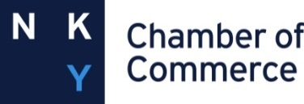

2019 Business Engagement of the Year Award Nomination Form
Nomination and Supporting Information Deadline: February 28, 2019
The 2019 Business Engagement of the Year Award will be presented to an area business engaged with a Northern Kentucky School or Schools, dedicated to improving student achievement through high impact partnership activities featured in the Business Engagement Toolkit.
Engagement opportunities featured (but not limited to) include the following focus areas/programs:

- Career Connections (mentoring, STEM activities, job shadowing, internships, Operation Preparation)
- Junior Achievement
- One to One: Practicing Reading and Math with Students
- Service Learning
- First Lego League
- Navigo Scholars
- Adopt a Class

Required Documents for Nomination Procedures:
- Letter of Support: To nominate a business making a difference, please provide documentation of the business contribution, not to exceed 2-pages, to demonstrate this successful business engagement. It is important to focus on measurable results and overall impact to the business, school and community.
- Supporting Documents: No more than 3 letters of support from students, parents and/or colleagues. Data, media accounts, personal testimonies, etc., may be included to help demonstrate excellence. Keep in mind that the selection committee’s decision will rest solely on the documentation provided.
Business Nominee:
Email:
Mailing Address:
City: State: Zip:
Nominated by:
School/Organization:
Email:
Mailing Address:
City: State: Zip:

Return this Nomination Form and Supporting Information via email by February 28, 2019 to:
Northern Kentucky Education Council, Attn: Staci Hunt Ramsey sramsey@nkyec.org
For more information or questions, please contact Staci Hunt ramsey at 859-282-9214 or sramsey@nkyec.org

