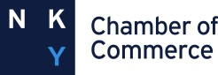
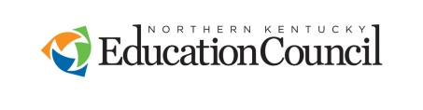

2019 STUDENT SERVICES AWARD
Nominees must have been responsible for school counseling innovations or further development of programs to support the career, personal/social and academic development of all students. Nominees must demonstrate leadership, advocacy and collaboration in their work and promote equity and access to opportunities and rigorous educational experiences for all students to maximize student achievement.
Examples of a Student Service nominee would be: FRYSC, Counselors,
School-based Therapists, etc.

Nominee’s Name
(Formal name please)
Email address

School, address and phone number for nominee

# Years Experience

Current Position

*******************************************************
Nominator’s Name
School/Organization
Position
Email address
Nominator’s day phone #
Principal’s signature

It is the responsibility of the nominator to get Principal approval for submission and signature of this nomination AND to inform this individual that they have been nominated for this award.

APPLICATION DEADLINE: February 28, 2019
Please complete the attached and return by email to cperkins@nkyec.org no later than Feb 28, 2019. PLEASE INCLUDE “2019 Student Services” IN YOUR EMAIL SUBJECT LINE.

Late entries, faxes and mail-ins will not be accepted.

If you have questions, please email or call:
Staci Hunt Ramsey at 859.282.9214 sramsey@nkyec.org

STUDENT SERVICE AWARD NOMINATION FORM

Required Documents for Nomination Procedure:
- Letter of Nomination-Not to exceed 2 pages
- Two additional letters of recommendation from school staff-Not to exceed 1 page each

Judging Criteria:

- Evidence of reducing barriers to learning
- Evidence of innovation in the development of programs/interventions to support the personal, social and career development of students.
- Evidence of leadership
- Evidence of advocacy
- Evidence of collaboration to promote equity and access to opportunities for students
- Evidence of working to maximize student achievement

